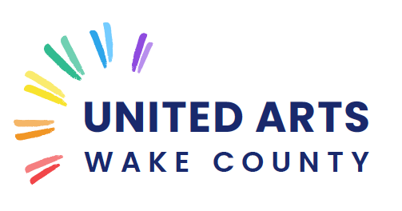

2024-2027

STRATEGIC PLAN

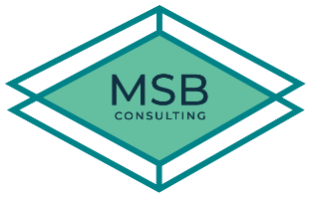
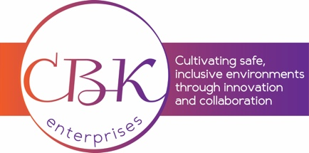
PREPARED BY:

A Vision for Artistic Excellence in Wake County

United Arts Mission
To build a better Wake County through the support of and advocacy for the arts.

United Arts Vision Statement
We envision a future where creativity and innovation are nurtured, where art and artists flourish, and where the arts are celebrated as an integral part of our cultural fabric.

United Arts Core Values
Community: We engage and collaborate with diverse partners to be responsive to the needs of Wake County.
Equity: Every individual is treated with respect and has access to participate in all dimensions of our work.
Integrity: We demonstrate honesty, transparency, and accountability in our work.
Stewardship: We manage resources responsibly while actively pursuing increased funds to adapt, innovate, and expand our positive impact.

The Plan
In partnership with consultants, data from community members, Board, and staff was collected and analyzed and teams of people connected to work through opportunities and challenges for United Arts.
Goals below have been aligned into our two large service areas of Community Support and Arts Education. The intent is for these strategic goals to inform operational goals and measurable milestones to be reached en route to completion. We are looking to identify competitive advantages, long term objectives, and organizational strategies for success.
The questions we have asked and are looking to solve: Who are we now? Who do we want to be to the community in the future? How does this plan get us further down that road?

The Community
On a high level, the community we support is all residents of Wake County as the designated local arts agency for the County government. We do this by engaging and collaborating with diverse partners to be responsive to the needs of County residents.
On a micro-level, we focus through an arts and culture lens. In this section, we define how we support the Wake County-based arts community through grant making, marketing, and professional development.
We use a broad definition of arts and culture. The definition includes music, theater, visual art, dance, and literary arts, and also creative expressions as traditional, ethnic, and folk art, culturally specific heritage initiatives, and historic preservation. The goal is for our definition of arts and culture to encompass our community’s customs, beliefs, and traditions.
By supporting and advocating for local artists and arts organizations we are growing the creative economy and economic impact from the arts for the broader community.

Goals, Strategies, Tactics
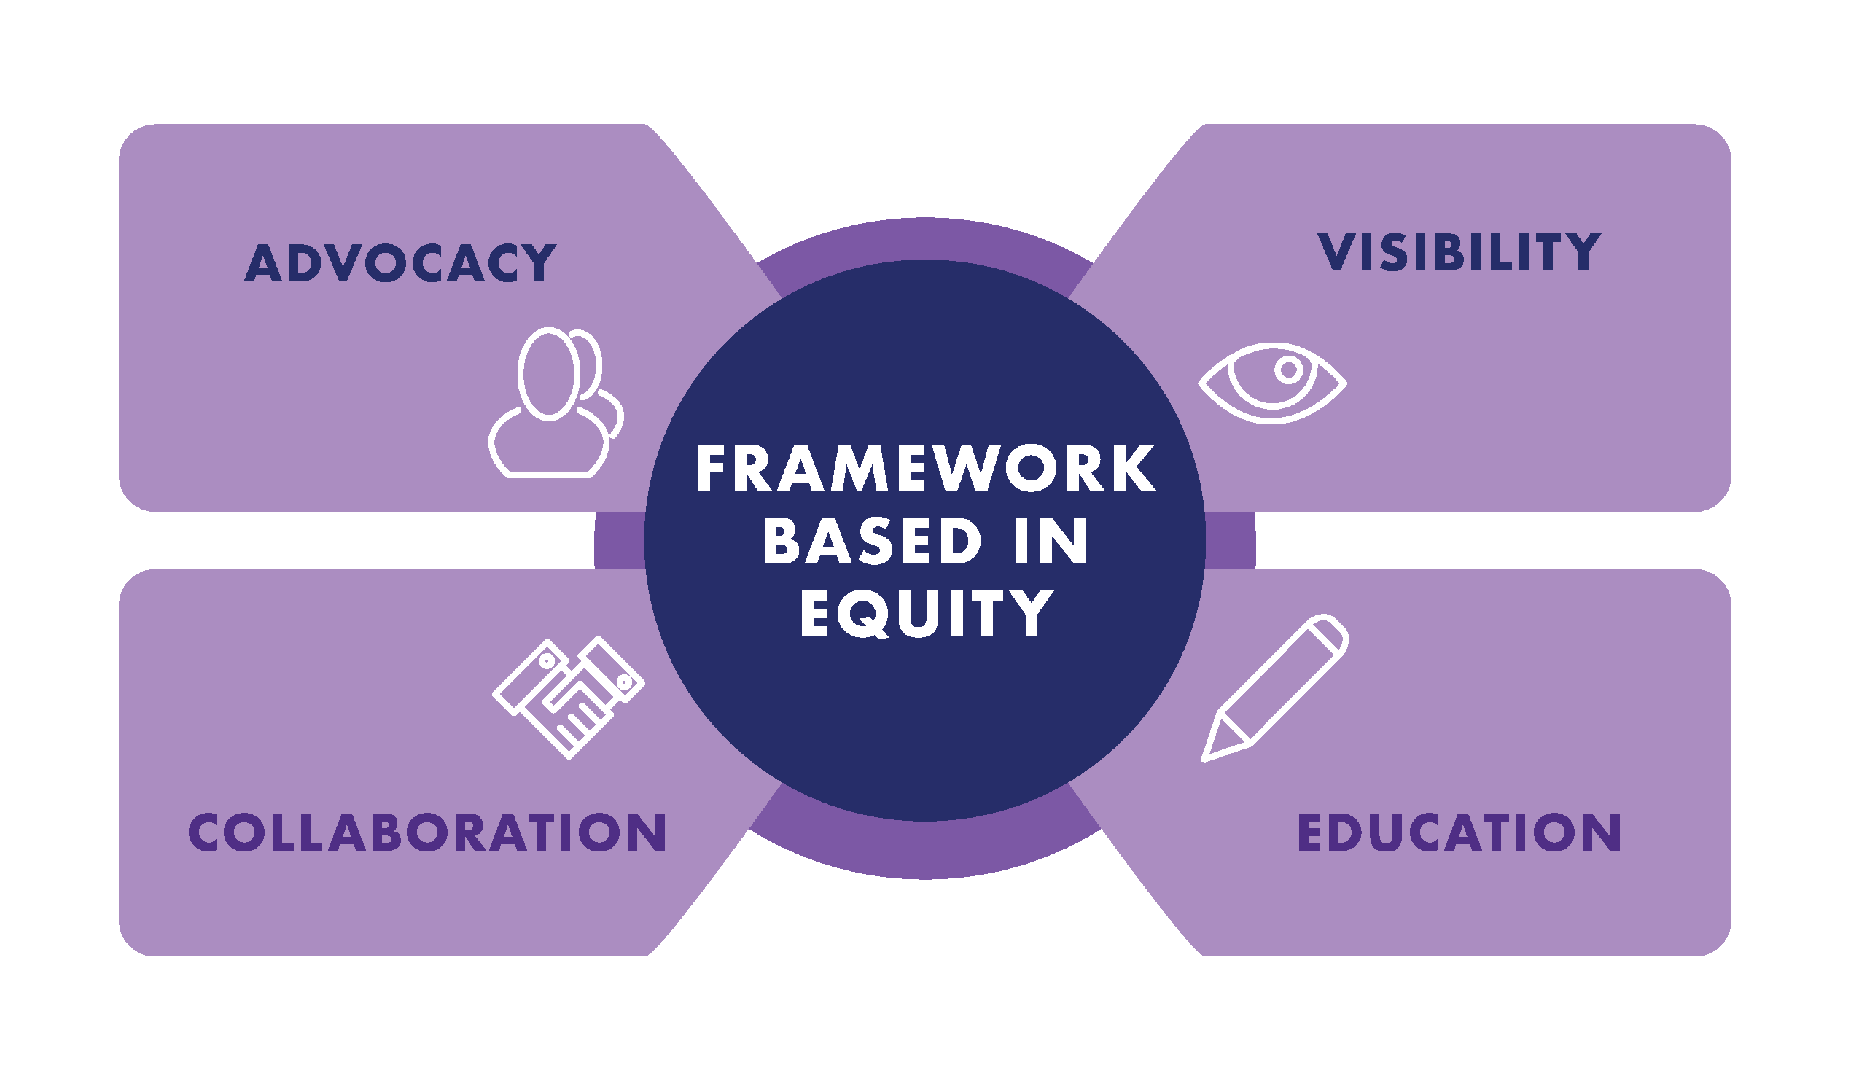

Goal 1: Diversify Funding to ensure long-term organizational viability
G1/S1: Increase contributed income with a focus on the corporate and business community
Tactics:
- Create a plan to inform the business community how UA contributes to the quality of life in Wake County
- Create a plan to inform the business community of the benefits of UA’s education and community programs
Responsible: Director of External Relations

G1/S2: Increase contributed income with a focus on major gifts
Tactics:
- Create a taskforce of the External Relations Committee to support this initiative
- Research prospects and survey current major donors
- Develop individual cultivation plans for donor prospects
- Create planned giving program to encourage inheritance or legacy gifts including demonstrating longevity of UA, how UA will utilize legacy gifts, and how donors will receive recognition
Responsible: Dir of External Relations & External Relations Committee

G1/S3: Develop earned revenue streams
Tactics:
- Determine full cost of free programs and underwrite fully from donations, partnerships, sponsorships, and grants
- Identify income generating activities and expand fee-based programming and classes
- Maximize revenue from income-generating activities by evaluating ROI
Responsible: CEO, VP of Programming, Dir External Relations, External Relations Committee

Goal 2: Maximize the impact of UA’s programming to build, broaden, and deepen service to the community
G2/S1: Develop County-wide Cultural Masterplan for Wake County Commissioners Adoption
Tactics:
- Work with identified consultants to survey community, research like communities, and establish task force to identify most relevant community needs
- Research and develop plan for County-wide creative placemaking initiatives for inclusion in plan
- Research space needs and revenue streams for arts sector
- Final plan due to Board of Commissioners by June 2025
Responsible: CEO

G2/S2: Evaluate and expand UA’s community outreach and support infrastructure
Tactics:
- Increase grant support for the arts to foster a creative community and drive economic growth
- Design and deliver professional development for Executive Directors in the arts sector
- Identify new temporary projects and programs that align with organizational values and community need
Responsible: VP of Programming & CEO

Education
Arts education is an important tool in closing learning gaps, heightening student engagement, and building community. Arts education envelopes visual arts, music, theater, dance, design, technology, architecture, videography, literary arts, and much more.
United Arts has dedicated much of its work in Wake County to supporting students and teachers with resources and arts experiences; and by supporting artists with an aptitude or interest to teach.
The successful outcomes of these programs have benefited both students and artists by sparking creativity, growing engagement, becoming a better citizen, expanding our workforce, and identifying new opportunities.

Goal 3: Maximize the impact of UA’s education programming to create greater access and deepen our service to the community
G3/S1: Evaluate and expand UA’s partnership with Wake County Public School System (WCPSS)
Tactics:
- Evaluate policies and practices for Artists in Schools grants and update program to maximize impact and ensure equitable distribution across the district
- Place Professional Teaching Artists in 100% of WCPSS Elementary and Middle Schools
- Expand Arts Integration training across the district
- Evaluate and update Pieces of Gold & Gifts of Gold partnership and outcomes
Responsible: VP of Programming, Dir of Education, CEO

G3/S2: Evaluate and expand UA’s arts education outreach, policies, and systems
Tactics:
- Assess and refine ROI of current educational offerings
- Expand successful collaborations with current community partners (RFAS, Empower All, Raleigh Arts, regional arts councils, grantees)
- Develop training program for professional artists to become teaching artists
- Collaborate with community partners, schools, municipalities to identify multi-generational programs in the arts
- Identify new sources of revenue for education initiatives

Responsible: VP of Programming, Dir of Education, CEO

Organization
United Arts has worked for more than 50 years to grow the cultural offerings across Wake County through grant programs to artists, arts organizations, and municipalities and through our robust education programs for Wake County students. We work daily to create a community where the arts are available and accessible to all 1.2M residents of Wake County.
Through the commitment to United Arts’ mission and the goals and strategies set forth in this plan, a new communication standard will be achieved to gain momentum as a team. Additionally, this plan will help identify areas to spend money effectively, make strategic purchasing decisions, and set our organization up to fundraise more productively than ever before. We will not fear experimentation, as taking calculated risks fuels innovation and will help us reach our mission more efficiently.
To ensure that United Arts is prepared to meet organizational challenges effectively and take advantage of new opportunities, the goals in this plan will need to be supported to ensure that the organization has the infrastructure, human resources, and capital needed to unlock its growth potential for the future.
While the majority of this work will be executed by United Arts professional staff, the board will provide oversight and resources to support the organization’s strategy.

Goal 4: Support the Board to achieve key organizational goals
G4/S1: Create an environment where all Board members actively engage in the work of UA
Tactics:
- Ensure all Board members have they information they need to fulfill their ambassadorial, fiduciary, and fundraising roles
- Update bylaws and other governing documents for compliance with best practices and EDI policies
- Provide ongoing learning opportunities for the Board
- Provide with regular updates on education and community programs including impact and outcomes
Responsible: CEO & Governance Committee

G4/S2: Build an inclusive Board that reflects UA’s constituents and contributes needed skills and resources to the organization
Tactics:
- Create and maintain a profile matrix for new member nominations to identify needs for UA in skills, personal attributes, and resources
- Recruit non-board members for committee service to augment pipeline of new Board members
- Tap talents and networks of Advisory Council members
Responsible: CEO & Governance Committee

Goal 5: Create an inclusive workplace that encourages collaboration and innovation

G5/S1: Enhance UA’s talent and infrastructure
Tactics:
- Recruit and retain a diverse staff with the skills and passion to further the mission
- Ensure UA is appropriately staffed to avoid burnout and turnover
- Develop an onboarding protocol and professional development opportunities for the staff
- Provide practical work experience and mentorship for interns
- Conduct an annual review of infrastructure needs including but not limited to technology, office space, event space, and human resources, and prioritize corrective activities
Responsible: Senior Staff & Executive Committee

