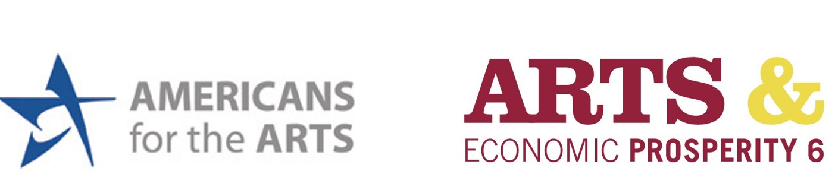

Hello!

My name is _____________ and I am with the <Organization Name>. We have a brief survey measuring arts-related spending that we would love for you to fill out. Are you interested in helping with our survey? We are the official study partner for Americans for the Arts’ latest national economic impact study, Arts & Economic Prosperity 6. This survey is part of a study to measure the economic impact of the arts and culture in <Community Name>. Your answers are completely anonymous. Please answer each question completely and return the survey to the person who gave it to you. Thank you!

Additional information about Arts & Economic Prosperity 6 Study:
<Organization Name> and <Community Name> have joined nearly 400 other U.S. communities to participate in Arts & Economic Prosperity 6, the largest national study every conducted to measure the economic impact of nonprofit arts and culture organizations and their audiences. This study is being conducted by Americans for the Arts, the nation’s leading nonprofit organization for advancing the arts and arts education. Arts & Economic Prosperity 6 will continue to demonstrate that the arts in Indianapolis mean business. It represents the sixth study of its kind conducted during the past 25 years.

According to Americans for the Arts’ previous national study, AEP5, the nonprofit arts industry generated $166.3 billion in total economic activity during fiscal year 2015, and supported 4.6 million full-time equivalent jobs, resulting in $27.5 billion in federal, state, and local government revenues. The $166.3 billion total included $63.8 billion in spending by arts organizations and $102.5 billion in event-related spending by their audiences on items such as meals, retail shopping, local transportation, and overnight lodging.

