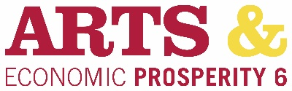
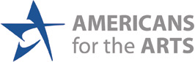

AN IMPORTANT SURVEY OF
ARTS & CULTURAL AUDIENCES
in Wake County

Please take a couple of minutes to answer the following questions about your attendance at this performance, event, exhibit, venue, or facility. This survey is being conducted by the United Arts Council of Raleigh and Wake County to measure the economic and social impact of arts and culture on Wake County. It will only take 2-3 minutes to participate. Your answers are completely anonymous. Thank you!

TO PARTICIPATE IN THE SURVEY:

- Open the camera on your smart phone. Older devices and operating systems may require a separate application—QR Code readers are available in the Apple App Store or Google Play.
- Focus your phone on the image below.
- Watch your phone screen for a web link to appear.
- Tap on the web link to open the survey.
- Follow the instructions to complete the survey.
- Click the yellow ➤ (arrow) button in the bottom righthand corner to finish.

